Use Case Specification

DMT/RM01/TMP

|  |  |
| --- | --- |
| Project Code | PROJECT_AMS_Add/Modify |
| Project Name | Asset Management System |

|  |  |  |
| --- | --- | --- |
| Prepared/Modified by | Role | Date of Preparation |
| Pranav | Test Engineer | 27/09/2018 |
| Reviewed by | Role | Date of Review |
| Anusha | SME |  |
| Approved by | Role | Date of Approval |
| Sapna | Test Manager |  |
| Circulation List |  | Version Number of the template: |
| Version Number | 1 |  |

<<Customer>> REVIEW HISTORY

<<Customer comments on the Use case along with the signed off is tracked here>>

|  |  |  |  |  |  |  |
| --- | --- | --- | --- | --- | --- | --- |
| Version | <<Version number>> |  |  |  |  |  |
| Date | <<Date of Review>> |  |  |  |  |  |
| Reviewed by | << Reviewer Name>> |  |  |  |  |  |
| Reviewed UI Specification doc | << Whether UI Specification doc is reviewed >> |  |  |  |  |  |
| All Open Queries/issues closed | << Whether all the open queries and issues resolved>> |  |  |  |  |  |
| Agreement on Assumptions | <<Whether all the assumptions have been agreed upon by the customer>> |  |  |  |  |  |
| Sign Off | <<Signature>> |  |  |  |  |  |

Disclaimer:

The scope of the project ‘<<Project Name>>’ is restricted to the contents of this signed off use case.

TABLE OF CONTENTS

1.Use Case Name: <<Use Case Name>> 4

2.Actor(s) 4

3.Preconditions 4

4.Flow of Events 4

4.1 Basic Flow 4

4.2 Alternative Flows 5

4.2.1 Alternate Flow 1 5

4.3 Sub Flows 6

4.3.1 Sub Flow 1 6

5.Post Conditions 6

6.Special Requirements 7

7.Extension Points 7

<Name of extension point> 7

8.Business Rules 7

9.Diagrams 8

Use Case Diagram 8

Activity Diagram 9

10.Scenarios 10

Success Scenarios 10

Failure Scenarios 10

11.Issues 10

12.UI Specifications 10

13.Inter System Dependencies 11

14.Integration with an already existing System of the <<Customer>> 11

15.Assumptions 11

REVISION HISTORY OF THE WORK PRODUCT…………………………….. .. 12

Use Case Name: Asset Management System Add/Modify

Use Case ID: Asset Management System Website

1.0

**Brief Description**: For admin this screen is available to add or modify or delete assets

Actor(s)

1. Admin

2. Asset Management Sysytem

Preconditions.

1. Website should be accessible by the Admin by visiting the website on the browser
2. The person logging in for Asset Management System should be a Admin.

Flow of Events

4.1 Basic Flow

**Name:** Successful Login of Asset Management System

1. Admin login into the website
2. Admin clicks Add/Modify Asset link
3. Admin clicks on add/modify/delete links
4. Admin clicks on ADD Asset
5. Admin enters asset name
6. Admin enters Description
7. Admin enters Quantity
8. Admin clicks on Submit Button
9. System displays the message “Successful Added/Modified/Deleted”
   1. Alternative Flows

1.Admin login into the website

2.Admin clicks Add/Modify Asset link

3.Admin clicks on add/modify/delete link

4.Admin enters asset name

5.Admin enters Description

6.Admin enters Quantity

7.Admin clicks on Submit Button

8.System displays the message “Successful Added/Modified/Deleted”

Alternate Flow 1:Successfull Add/Modify in Asset Management System

Exception Flow 1: unsuccessfull Add/Modify in Asset Management System due To invalid Asset name

1. Admin login into the website

2.Admin clicks Add/Modify Asset link

3.Admin clicks on add/modify/delete links

4.Admin enters asset name

5.Admin enters Description

6.Admin enters Quantity

7.Admin clicks on Submit Button

8.System displays the message “Invalid Assetname”

Exception Flow 2 :unsuccessful Add/Modify in Asset System due to invalid Quantity

1. Admin login into the website
2. Admin clicks Add/Modify Asset link
3. Admin clicks on add/modify/delete links
4. Admin enters asset name
5. Admin enters Description
6. Admin enters Quantity
7. Admin clicks on Submit Button
8. System displays the message “Invalid Quantity”

Exception Flow 3 :unsuccessful Add/Modify in Asset System due to Web Server Down

1. Admin login into the website
2. Admin clicks Add/Modify Asset link
3. Admin clicks on add/modify/delete links
4. Admin enters asset name
5. Admin enters Description
6. Admin enters Quantity
7. Admin clicks on Submit Button
8. System displays the message “Web Server Down”

Exception Flow 4 :unsuccessful Add/Modify in Asset System due to Database Connectivity Error

1. Admin login into the website
2. Admin clicks Add/Modify Asset link
3. Admin clicks on add/modify/delete links
4. Admin enters asset name
5. Admin enters Description
6. Admin enters Quantity
7. Admin clicks on Submit Button
8. System displays the message “Database Connectivity Error”

Exception Flow 5:unsuccessful Add/Modify in Asset System due to Network Connectivity Error

1. Admin login into the website
2. Admin clicks Add/Modify Asset link
3. Admin clicks on add/modify/delete links
4. Admin enters asset name
5. Admin enters Description
6. Admin enters Quantity
7. Admin clicks on Submit Button
8. System displays the message “Network Connectivity Error”

Post Conditions

| Flow Name | Post Condition |
| --- | --- |
| Successful Add/Modify/Delete in Asset Management System | System displays the message “Successful Message” |
| Unsuccessful Add/Modify in Asset Management System due to invalid asset name | System displays the error message “Enter valid assetname” |
| Unsuccessful Add/Modify in Asset Management System due to invalid password | System displays the error message “Enter Correct Quantity of Asset” |
| Web Server Down | The system should display an error message to the user regarding web server unavailability problem. |
| Database Connectivity Error | The system should display an error message to the user regarding the database connectivity problem. |
| Network Connectivity Error | The system should display an error message to the user regarding the network connectivity problem. |

Special Requirements

Performance

The Admin should receive a mail regarding all the details entered after successfully added or modified assets.

Availability

* 1. Application is up and running 24*7.

Business Rules

| Business Rule Name | Business Rule Description | System action (if BR fails) |
| --- | --- | --- |
| BR01 | All fields must be selected | Error message is displayed if any field is not selected |
| BR02 | Valid assetname must be entered | Error message is displayed if invalid |
| BR03 | Valid quantity must be entered | Error message should be displayed if invalid |

Diagrams

Use Case Diagram

* 1. For Successful Asset Management System
     1. Admin

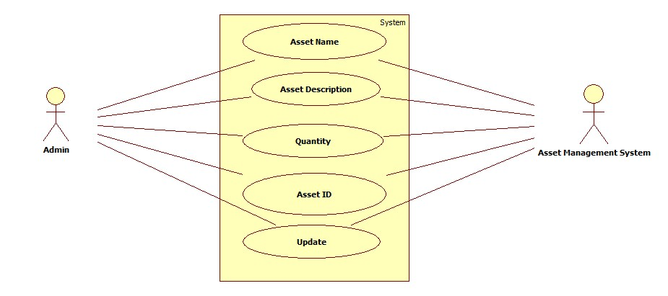

Scenarios

Success Scenarios

* Successfully Assets Added/Modified in Asset Management System

Failure Scenarios

* Failed Asset Add/Modified in Asset Management System for entering invalid assetname
* Failed Asset Add/Modified in Asset Management System for not entering invalid quality

Issues

1. What is to be done if web server is down?
2. What is to be done if the Add/modify link does not get opened?
3. What is to be done if there is data connectivity error?
4. What is to be done if the form is not getting submitted even after entering valid field details without any alerts for errors?

Extension Points

Extension in Alternate FLOW 1:

In step 1, of alternative flow 1 if the Admin clicks on Submit Button

1. The Admin can enter all the details again.

Assumptions

1.Admin can easily login.

2.The Admin has selected and entered all the fields.

REVISION HISTORY OF THE WORK PRODUCT

<to be maintained by projects>

|  |  |  |  |  |  |
| --- | --- | --- | --- | --- | --- |
| # | Date | Version # | Section Changed | Details of changes made | Approved By |
| 1 |  |  |  |  |  |
| 2 |  |  |  |  |  |